Project Title
Academic Guidance and Motivation Intelligence System (AGMIS)

Project Description
The Academic Guidance and Motivation Intelligence System (AGMIS) is a data-driven academic support system designed to help students stay aligned with the semester syllabus.
The system compares expected academic progress, defined by faculty syllabus timelines, with actual student performance data such as attendance, internal marks, and assignment submission status.
Based on this comparison, the system provides academic guidance, motivation feedback, and progress insights to students throughout the semester.
The purpose of the system is to identify academic lag early and support students before examinations, rather than evaluating performance only at the end of the term.

Problem Statement
In many colleges, students face academic difficulties such as low attendance, incomplete syllabus coverage, and poor internal marks. These issues are usually identified during examinations, when corrective action becomes difficult.
Although faculty follows a planned syllabus schedule, there is no automated system to track whether students are progressing according to the expected academic timeline.
This delay in academic feedback leads to stress, low motivation, and weak academic outcomes. Hence, there is a need for a system that provides continuous academic guidance and motivation using data analysis.

Project Objectives
- To design a system based on faculty-defined syllabus timelines.
- To analyze student academic data such as attendance and internal marks.
- To calculate expected versus actual academic progress.
- To identify early academic deviation using statistical analysis.
- To provide personalized academic guidance messages.
- To motivate students using progress indicators and achievements.
- To maintain transparency and privacy in academic monitoring.

System Architecture Overview
The system consists of the following modules:
- Faculty Input Module
- Student Academic Data Module
- Data Preprocessing Module
- Progress Analysis Engine
- Guidance and Motivation Engine
- Student Dashboard Interface

📌 SYSTEM ARCHITECTURE DIAGRAM
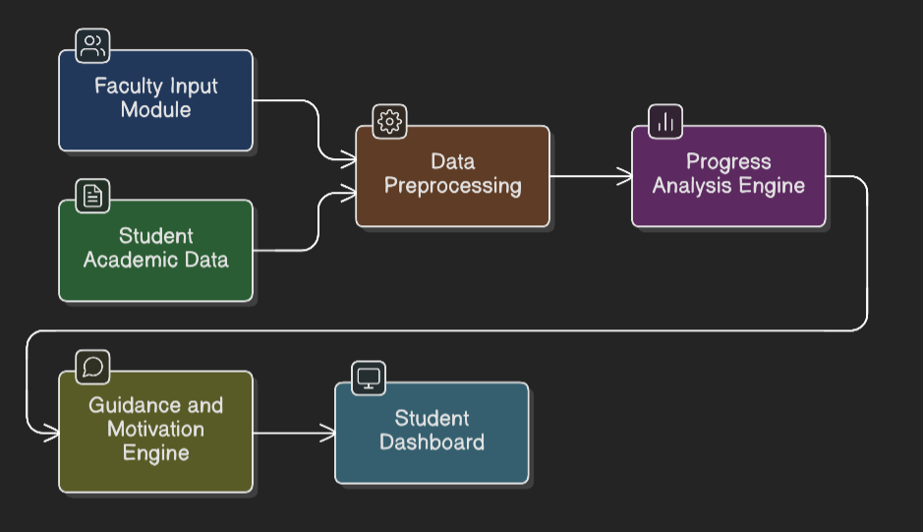

System Working
- Faculty uploads syllabus structure, unit timelines, and assessment plan.
- Student academic records such as attendance and marks are collected.
- Data is cleaned and standardized for analysis.
- Expected academic progress is calculated for each week.
- Actual student progress is compared with expected progress.
- Deviation and batch percentile are computed.
- Guidance messages and motivation feedback are generated.
- Results are displayed on the student dashboard.

📌 SYSTEM WORKFLOW DIAGRAM
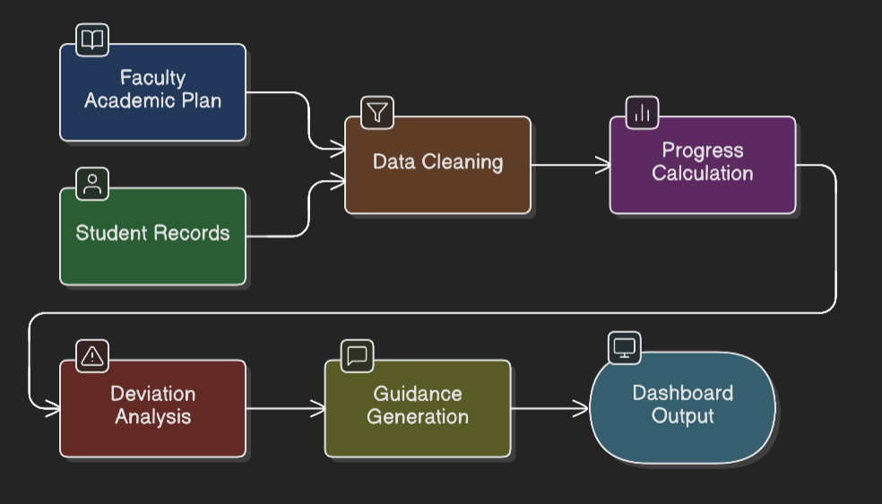

Student Dashboard (What Student Sees)
The student dashboard displays:
- Current academic progress
- Expected syllabus completion level
- Progress gap (ahead or behind)
- Batch percentile position
- Weekly academic guidance messages
- Motivation badges and achievements

📌 IMAGE 3 – STUDENT DASHBOARD VIEW

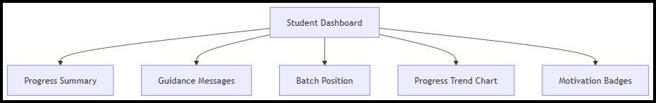

Tools and Technologies Used (Free Only)
- Programming Language: Python 3
- Data Analysis: Pandas, NumPy
- Statistical Analysis: SciPy
- Visualization: Matplotlib
- Dashboard Development: Streamlit
- Data Storage: CSV / SQLite
- Development Environment: VS Code
- Version Control: GitHub
Cost of implementation: ₹0 (Open-source tools only)

Sample Progress Chart Code
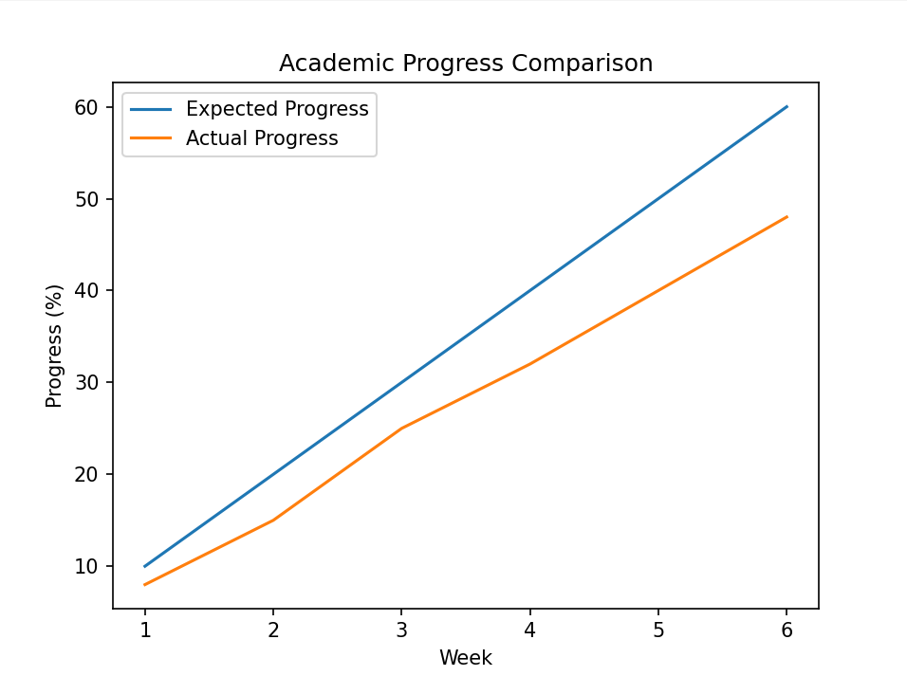

Ethical Considerations
- No personal behavioral tracking
- No surveillance or monitoring of private activity
- Analysis based only on academic records
- Guidance-oriented, not punishment-based

Expected Outcome
- Early identification of academic lag
- Improved attendance and engagement
- Better syllabus alignment
- Increased student motivation
- Reduced exam-time academic stress

Conclusion
The Academic Guidance and Motivation Intelligence System aims to provide continuous academic support using data-driven insights. The system helps students understand their academic standing early and encourages consistent learning throughout the semester.

